**FERTILIZER RECOMMENDATION SYSTEM FOR DISEASE PREDICTION**

**SOLUTION ARCHITECTURE**

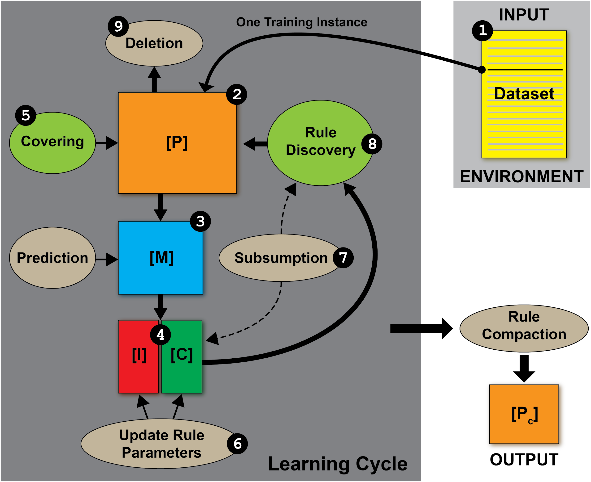

| **NAME** | **1.MATHIARASI.J(TEAM LEADER)**  **2.KAVIPRIYA.R**  **3.SANDHIYA.P**  **4.MAMTHA.M**  **5.SAABIRA.S** |
| --- | --- |
| **DATE** | **31 October 2022** |
| **MAXIMUM MARKS** | **4 Marks** |
| **MARKS ALLOTTED** |  |

**Support Vector Machine**

**SVM develops a hyperplane or set of hyper planes in a high-or boundless dimensional space, which can be utilized for characterization, relapse, or different errands. Naturally, a great partition is accomplished by the hyperplane that has the biggest separation to the closest preparing information purpose of any class, since by and large the bigger the edge the lower the speculation blunder of the classifier. The computational burden has to be reasonable, the mappings are utilized by the SVM plan to guarantee the tiny items will be figured as far as the variable in the first degree, for that a bit capacity k(x, y) chose to get the ideal computational time.**

**Advantages**

**1) SVM calculation has a regularization parameter, which stays away from over-fitting.**

**2) SVM calculation utilizes the portion trap, so you can construct master learning about the issue.**

**RANDOM FOREST ALGORITHM:**

**Random forest is a supervised machine learning algorithm based on ensemble learning. Ensemble learning is a type of learning where you join different types of algorithms or the same algorithm multiple times to form a more powerful prediction model. The random forest algorithm combines multiple algorithms of the same type. Random Forest algorithms can be used for classification and regression problems.**

**Advantages**

**1) The random forest algorithm is not biased, since there are multiple trees and each tree is trained on a subset of data.**

**2) Random Forest algorithm is stable if a new data point is introduced in the dataset the overall algorithm is not affected.**

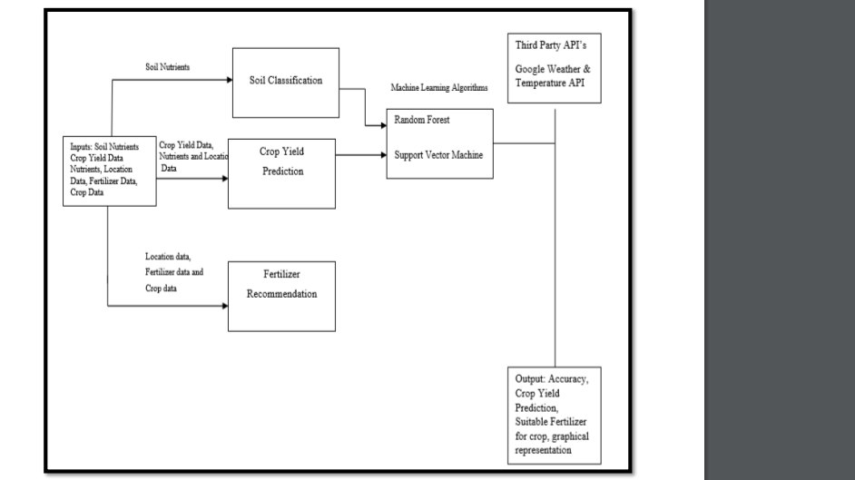

**SOLUTION ARCHITECTURE**